Week -10 Generative AI
Lecture Objectives
• Understand Generative AI
• Explore applications
• Discuss ethics
• Design AI solutions
What is Generative AI?
AI systems that generate new content.
Examples of Generated Content
• Text
• Images
• Music
• Code
• Video
LLMs Overview
Large Language Models (LLMs) learn patterns from text.
How LLMs Work
LLMs predict the next word in a sequence.
Prompt Engineering
Better prompts produce better outputs.
Prompt Activity
Students write a prompt for a LinkedIn post.
Example: Write about generative AI in education.

Improve Their Prompt
• Role
• Context
• Style
• Length
• Audience
• Structure
Example Strong Prompt:
“Act as an AI education expert.
Write a professional LinkedIn post about how generative AI is transforming higher education.
Include:
• one real-world example
• one challenge universities face
• one question to engage readers
Tone: professional and inspiring
Length: 120 words”
The 6 Elements of Great Prompts:
1. Role
2. Task
3. Context
4. Format
5. Constraints
6. Tone
Example:
Act as a marketing expert.
Write a LinkedIn post explaining the impact of generative AI on digital marketing.
Audience: marketing professionals
Include: one statistic and one example
Tone: professional but engaging
Length: 100 words

Possible Questions That Could Produce Hallucinations
1. Very General Question
Who created the first artificial intelligence program?
When prompts are too vague, AI may fill missing information and hallucinate details.
2. Leading Question
When was the first AI program created and who developed it?
This forces the model to produce specific details even if uncertain.
3. Historical Question
What was the first artificial intelligence system and who invented it?
The AI might attempt to generate a complete narrative, increasing hallucination risk.
4. Overly Specific Question
Describe the first artificial intelligence program developed by Alan Turing and John McCarthy.
This assumes a fact that is not true, so the model may invent supporting details.
Hallucinations often happen when:
• Questions are vague
• Prompts contain incorrect assumptions
• The AI is forced to produce precise historical facts
Small Prompt Changes Can Produce Different Results
Prompt 1: Give career advice to someone who wants to become a data scientist but hates math.
Prompt 2: Give funny career advice to someone who wants to become a data scientist but hates math.
Prompt 3: Act as a career counselor and give practical advice to a student who wants to become a data scientist but dislikes mathematics.
Each prompt leads to different outputs.
AI responses are not deterministic like calculators.

Popular Text-to-Image AI Models
1️⃣ DALL·E (Developed by OpenAI)
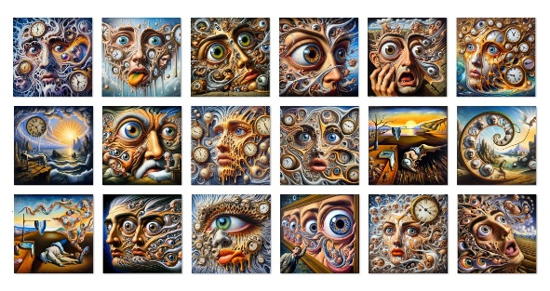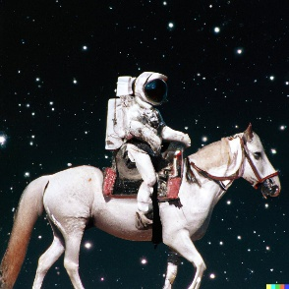
Layman explanation:
Think of DALL·E as a creative assistant that easily turns your description into an image.
Example prompt:
A panda riding a bicycle in a futuristic city.
DALL·E quickly generates a creative picture.
When to use it
Use DALL·E when you want:
- simple image creation
- quick visuals
- creative ideas
- educational demonstrations
It is very easy for beginners.
Integrated into ChatGPT and other tools

2️⃣ Midjourney
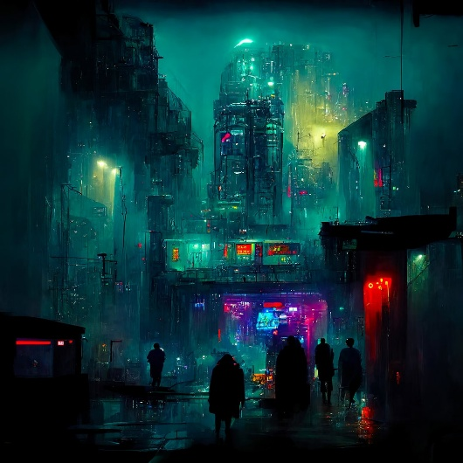

Layman explanation
Midjourney is like a professional digital artist.
It produces very beautiful and cinematic images.
Example prompt:
A futuristic cyberpunk city with neon lights at night.
When to use it
Use Midjourney when you want:
- artistic images
- posters
- concept art
- creative design
Designers love it because the images look very artistic.

3️⃣ Stable Diffusion
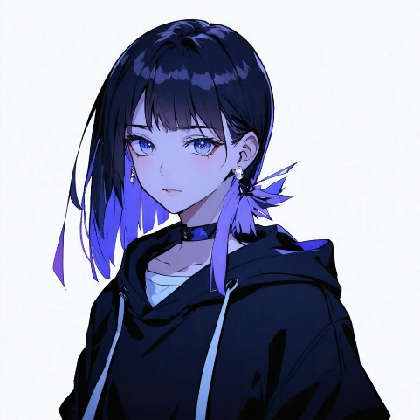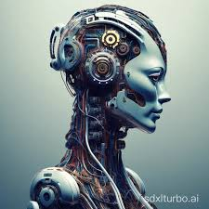

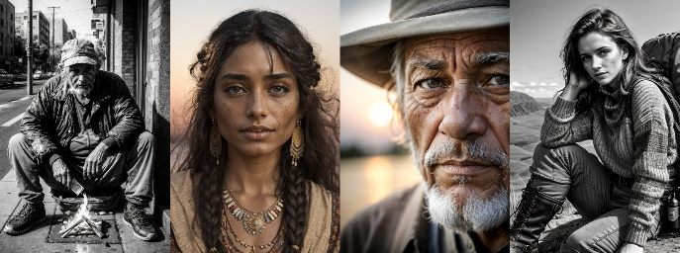
Layman explanation
Stable Diffusion is like a DIY AI artist.
You can run it on your own computer and customize it.
When to use it
Use Stable Diffusion when you want:
- full control
- customization
- research experiments
- building your own AI tools
Developers and researchers use it more.

Real-World Applications of Generative AI
Explain where these tools are used in industry.
Design and Marketing
Companies use AI to create:
- advertisements
- posters
- social media graphics
- product images
Example: A marketing team generates product images using AI instead of hiring photographers.

Entertainment and Gaming
AI helps create:
- concept art
- characters
- game environments
- movie storyboards
Example:
A game designer generates fantasy landscapes for a video game.

Education
Teachers use AI to create:
- diagrams
- visual explanations
- teaching materials
Example:
A teacher generates an image of “the solar system in cartoon style” for students.

Product Design
Designers use AI to generate:
- furniture designs
- clothing ideas
- architecture concepts

Limitations of Generative AI
This is a very important concept for students.
Explain that AI is powerful but not perfect.
Common issues:
Weird Details
AI images sometimes produce:
- extra fingers
- distorted faces
- strange objects
Explain why:
AI predicts patterns but does not truly understand objects.

Hallucinations
Generative AI can produce incorrect information confidently.
Example:
Fake facts or made-up references.

Bias
AI models learn from training data, so they can reflect biases in the data.

Ethical Issues
Introduce the ethical discussion.
Ask students:
What problems could AI-generated images cause?
Students might say:
- fake images
- copyright problems
- misinformation
- deepfakes

Simple Comparison:
Tool | Think of it as | Best for
DALL·E | Easy AI assistant | quick image creation
Midjourney | Professional digital artist | beautiful artwork
Stable Diffusion | DIY customizable AI | developers & researchers

Music Generation
Explain that AI can generate songs and melodies.
Example tools:
- AIVA
- Google Magenta
Example use:
- background music
- game soundtracks
- personalized music

Code Generation (Important for Students)
Explain that AI can write computer programs.
Example tool:
- GitHub Copilot
Example prompt:
Write a Python function that calculates the factorial of a number.
Explain:
AI can help developers with:
- writing functions
- debugging code
- generating documentation
Video Generation
Explain that AI can generate videos from text prompts.
Example tools:
- Runway
- Sora
Example prompt:
A short video of a robot teaching a classroom.
Explain:
AI can create short films, animations, and ads.

Speech Synthesis Advances:
Neural Voice Cloning: Creating synthetic voices from small audio samples
Emotional Speech: Adding emotional expression to text-to-speech
Multilingual Models: Supporting voice synthesis in multiple languages
Real-time Generation: Low-latency speech synthesis for interactive applications

Napkin AI
Napkin AI turns text ideas into visual diagrams automatically.
Example:
Student writes:
Steps of machine learning:
1. Data collection
2. Data cleaning
3. Model training
4. Prediction
Napkin AI converts this into a flowchart or diagram.

AI Productivity Tools:
Tool | Use
ChatGPT | text generation
DALL·E | image generation
Runway | video generation
Napkin AI | visual diagrams

